Error from BU data

Employee_lab:

1. Some of the id has a large difference lab_visit_date with labreq_drawn_date and labreq_completed_date.

e.g.

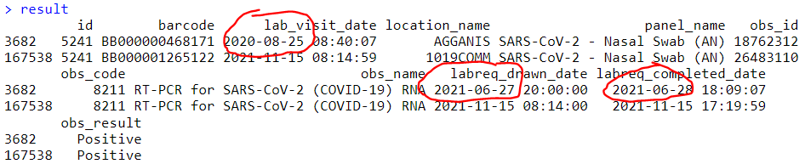

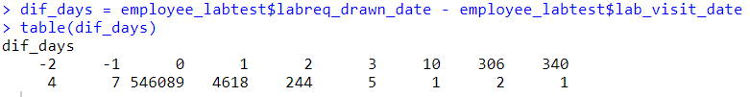

Students

1. If the infected person did several tests in a continuous date frame, how to get the reported cases (tested date) 🡪 the date duration for the next infection? (BU students have daily check during the isolation)